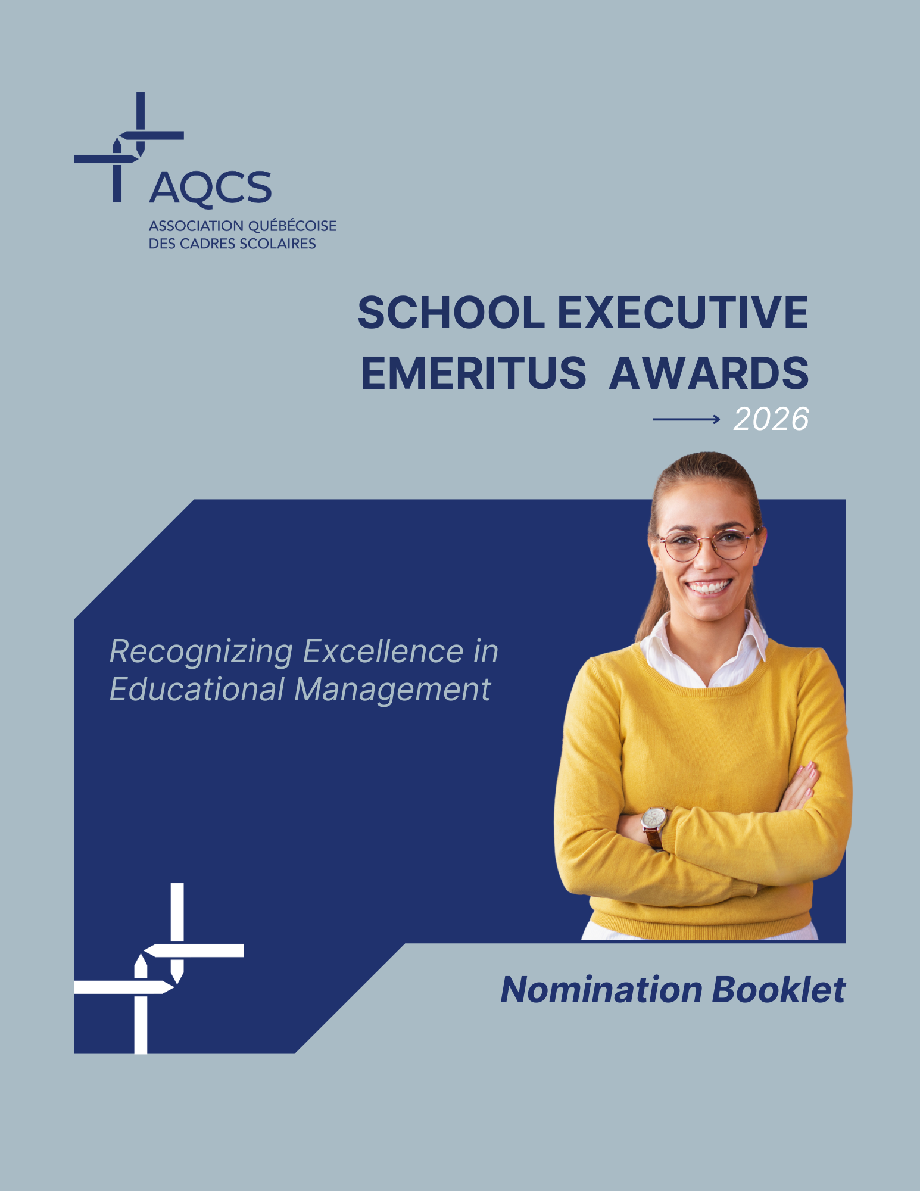

Cliquez ou appuyez ici pour entrer du texte.

2025 RECIPIENTS

 | CAREER ACHIEVEMENT | France Migneault  Manager, Consultation Project for the Laval–Laurentides–Lanaudière Region  CSS de Laval  In addition to coordinating extensive organizational reflection initiatives throughout her career, Ms. Migneault developed an integrated support and consultation model for students with disabilities or with adjustment or learning difficulties.
 | LEADERSHIP | Julie Martineau  Coordinator, Teaching and School Transportation Services  CSS des Hauts-Cantons  Ms. Martineau’s strategic and mobilizing approach enabled the CSS to overcome significant management challenges. Her achievements include improving transportation routes, enhancing safety surrounding schools, and managing end-of-life school buses.
 | INNOVATION | Jérémi Forgues  Director, Material Resources and School Transportation Services  CSS de Charlevoix  Mr. Forgues uses material resources management as a strategic lever for educational innovation. Comfort, sustainability, inclusion, and ergonomics are integral to all the projects he leads. He managed the construction of École des Eaux-Vives, considered one of Québec’s most energy-efficient public buildings.
 | EMERGING TALENT | Maude Boudreault-Bordeleau  Assistant Director, Information Technology Services  CSS des Grandes-Seigneuries  This award recipient stands out within her organization for her rigour, strategic vision, and local and national involvement in reflecting on the challenges and professional positioning of IT teams within CSS-CS organizations. Notably, she implemented an information security program to meet ministerial requirements and ensure organizational compliance.

TEAM ACHIEVEMENT
Project: Virtual Platform for Professional Integration and Development for School-Based Educators
CSS des Patriotes: Andrée Chicoine, Marie-Michèle Mercier, Karen Brassard, Stéphanie Burelle, Catherine Lussier-Cardinal, Julie Ducasse, Marie-Pierre Laflamme, Catherine Garand
These managers from various CSS services (school organization, educational resources, human resources, and financial services) combined their expertise to develop a platform that brings together continuing professional development tools for school daycare teams in CSS elementary schools.

To learn more about these school administrators: www.aqcs.ca

 | The School Executive Emeritus Award highlights excellence among school administrators working in the administrative centres of school service centres and school boards, adult education and vocational training centres, as well as elementary and secondary schools.

— FIVE AWARD CATEGORIES
The application must be submitted for one of the following five categories. There is a different form for each category in this booklet.
- Career Achievement: Honours a school executive with an outstanding career path and achievements.
- Team Achievement: Honours two or more school executives who have combined their expertise to carry out a major project aimed at improving the efficiency of their organization.
- Innovation: Honours an executive with leading-edge practices who has implemented innovative, creative or bold projects and processes.
- Emerging Talent: Honours an outstanding school executive who has been in the job for less than five years.
- Leadership: Honors a school executive with more than five years' management experience, whose mobilization skills, strategic vision and courage have enabled the organization to achieve its objectives or improve its results.

— NOMINATIONS
- The completed nomination form, along with a photo and a short video, must be sent to AQCS head office no later than May 11, 2026.
- The email address is indicated at the end of the nomination booklet.
- All AQCS members may submit nominations.
- Members of the Selection Committee may not submit nominations.
- Nominations must be supported by two executive members.

— ELIGIBILITY REQUIREMENTS
- Be an active member of the AQCS by December 31, 2025.
- Only applications that are completed in the nomination booklet and comply with the requirements will be considered.

— 2026 SELECTION COMMITTEE
The committee's mandate is to evaluate the applications and select the winners. It is composed of five members:
- Wen Ching-Chang, Chairman of the Board, AQCS
- Jean-François Parent, CEO, AQCS
- Mélanie Boisselle, Co-President of the Commission professionnelle des services des ressources humaines, AQCS
- Marie-Claude Asselin, General Manager, Centre de services scolaire des
Premières-Seigneuries
- Annie Tremblay, Interim General Manager, Centre de services scolaire du Pays-des-Bleuets
- André Bernier, President, Association québécoise du personnel de direction des écoles

— AWARDING OF THE PRIZE
Applicants will be contacted in June 2026 with details of the awards ceremony.

 | Form 1  CAREER ACHIEVEMENT CATEGORY | This category honours a school executive with an outstanding career path and achievements.

☐ I enclose a recent photo of the nominee (JPG).   | ☐ I enclose a presentation video: see page 10 for instructions.

Candidate

Name Click or tap here to enter text . Position Click or tap here to enter text.
CSS-CS Choose your CSS-CS.

Identification of nominator submitting the application Names of two supporting executive members
Name | Click or tap here to enter text. | Name | Click or tap here to enter text.
Position | Click or tap here to enter text. | Name | Click or tap here to enter text.
CSS-CS | Choose your CSS-CS.

Achievements (45% of points)
Describe the candidate's professional achievements or innovative practices that have created value and contributed to the quality of services for the student, staff, parents or community of your school service center or school board. (200 words)
Click or tap here to enter text.

Professional commitment (45% of points)
Describe the candidate's distinctive qualities, skills and competencies: strategic leadership, proactive and effective management, ability to mobilize teams, expertise, innovation, collaborative approach, etc. (300 to 500 words)
Click or tap here to enter text.

Community involvement (10% of points)
Mention any other professional or personal contributions by the candidate that have helped enhance the visibility and reputation of the school service centre or school board at the regional or national level. (100 words)
Click or tap here to enter text.
Complete the nomination on page 10 of this booklet.
 | Form 2  TEAM ACHIEVEMENT CATEGORY | This category honours two or more school administrators who have combined their expertise to carry out a major project aimed at improving the efficiency of their organization.

☐ I enclose a recent photo of the nominee (JPG). | ☐ I enclose a presentation video: see page 10 for instructions.

Candidate

Names and Positions Click or tap here to enter text.
CSS-CS Choose your CSS-CS.

Identification of nominator submitting the application Names of two supporting executive members
Name | Click or tap here to enter text. |  | Name | Click or tap here to enter text.
Position | Click or tap here to enter text. |  | Name | Click or tap here to enter text.
CSS-CS | Choose your CSS-CS.

Presentation (40% of points)
Describe the project completed by this team and its impact on the organization in terms of efficiency.
(300 to 500 words)
Click or tap here to enter text.

Profiles (20% of points)
Summarize the career path of the executives involved or describe the strengths or particularities of the nominated team. (200 words)
Click or tap here to enter text.

Collaboration (40% of points)
How did the executives work together in synergy? How did their combined expertise and skills benefit the success of the project? (300-500 words)
Click or tap here to enter text.

Complete the nomination on page 10 of this booklet.
 | Form 3  INNOVATION CATEGORY | This category honours an executive with leading-edge practices who has implemented innovative, creative or bold projects and processes.

☐ I enclose a recent photo of the nominee (JPG). | ☐ I enclose a presentation video: see page 10 for instructions.

Candidate

Name Click or tap here to enter text. Position Click or tap here to enter text.
CSS-CS Choose your CSS-CS.

Identification of nominator submitting the application Names of two supporting executive members
Name | Click or tap here to enter text. | Name | Click or tap here to enter text.
Position | Click or tap here to enter text. | Name | Click or tap here to enter text.
CSS-CS | Choose your CSS-CS.

Profile (40% of points)
Summarize the background of the executive involved, highlighting his/her leading practices (300-500 words)
Click or tap here to enter text.

Achievements (40% of points)
Describe the innovative, creative or bold projects or processes implemented in your organization by this executive. (300 to 500 words)
Click or tap here to enter text.

Outreach (20% of points)
Has this executive's sense of innovation inspired other initiatives, led to new practices within the organization?
(200-500 words)
Click or tap here to enter text.

Complete the nomination on page 10 of this booklet.
 | Form 4  EMERGING TALENT CATEGORY | This category honours an outstanding school executive who has been in the position for less than 5 years.

☐ I enclose a recent photo of the nominee (JPG). | ☐ I enclose a presentation video: see page 10 for instructions.

Candidate

Name Click or tap here to enter text. Position Click or tap here to enter text.
CSS-CS Choose your CSS-CS.

Identification of nominator submitting the application Names of two supporting executive members
Name | Click or tap here to enter text. | Name | Click or tap here to enter text.
Position | Click or tap here to enter text. | Name | Click or tap here to enter text.
CSS-CS | Choose your CSS-CS.

Presentation (20% of points)
Summarize the candidate's career path. (200 words)
Click or tap here to enter text.

Profile (40% of points)
Describe the skills or abilities that make this executive a promising future educational leader. (300-500 words)
Click or tap here to enter text.

Achievements (40% of points)
Describe the candidate's professional achievements in your organization. (300 to 500 words)
Click or tap here to enter text.

Complete the nomination on page 10 of this booklet.

 | Form 5  LEADERSHIP | This category honours a school executive with more than 5 years' management experience, whose mobilization skills, strategic vision and courage have enabled the organization to achieve its objectives or improve its results.

☐ I enclose a recent photo of the nominee (JPG). | ☐ I enclose a presentation video: see page 10 for instructions.

Candidate

Name Click or tap here to enter text. Position Click or tap here to enter text.
CSS-CS Choose your CSS-CS.

IdenItification of nominator submitting the application Names of two supporting executive members
Name | Click or tap here to enter text. | Name | Click or tap here to enter text.
Position | Click or tap here to enter text. | Name | Click or tap here to enter text.
CSS-CS | Choose your CSS-CS.

Presentation (20% of points)
Summarize the candidate's career path. (200 words)
Click or tap here to enter text.

Profile (50% of points)
Describe how this person's leadership style has influenced your organization's results. (300-500 words)
Click or tap here to enter text.

Outreach (30% of points)
Has this executive's ability to mobilize, his or her strategic vision and courage had a ripple effect in your community? (300 to 500 words)
Click or tap here to enter text.

Complete the nomination on page 10 of this booklet.
TO FINALIZE THE NOMINATION

— VIDEO PRESENTATION OF THE CANDIDATE
This step is mandatory. Attach a video of no more than 40 seconds that highlights the application. It can be recorded by cell phone (in horizontal format). This video will be used to promote the finalists on AQCS platforms. It will not be presented to the selection committee.
Click here to submit your video. Password: PCSE2026
Please identify the individuals in the video:
Name: Cliquez ou appuyez ici pour entrer du texte. Position: Cliquez ou appuyez ici pour entrer du texte.
Name: Cliquez ou appuyez ici pour entrer du texte. Position: Cliquez ou appuyez ici pour entrer du texte.
Name: Cliquez ou appuyez ici pour entrer du texte. Position: Cliquez ou appuyez ici pour entrer du texte.
Name: Cliquez ou appuyez ici pour entrer du texte. Position: Cliquez ou appuyez ici pour entrer du texte.
Uploading your video may take several minutes. Once the video has been uploaded, the file name will appear below the upload window.
A FEW SUGGESTIONS:
- In the introduction, name your CSS-CS, the candidate's name and title.
- Complete the form, indicating why you are applying (achievements, outstanding skills).
- Draw inspiration from the videos produced in 2025.
- If you have any questions: mcloutier@aqcs.ca

— CONSENT TO APPLY
The candidate accepts that his or her nomination be publicized by AQCS and that his or her photo and a brief description of his or her achievements be published in AQCS communication tools (social media, InformAQCS, website), in the communication tools of his or her school service center or school board, and in any AQCS communication tool that will recall the event.

By signing, the nominee certifies the accuracy of the facts presented in the nomination form and authorizes their publication.

Applicants and recipients will be contacted in June 2026 with details of the awards ceremony.

Signature of the candidate Date

For the Team Achievement category, the signature of a candidate representing the team is sufficient.

Signature of the candidate Date

— SUBMISSION OF NOMINATION FORM: MAY 11, 2026
By email: mcloutier@aqcs.ca
Information: 418 654-0014, poste 233

5600, boulevard des Galeries, Suite 610
Quebec, Quebec G2K 2H6
Phone: 418 654-0014
Fax: 418 654-1719


AQCS.CA

